

SIMATS ENGINEERING
Saveetha Institute of Medical and Technical Sciences Chennai- 602105

Student Name : Sanjana . G
Reg. Number : 192511020
Course Code : CSA0764 Slot: A
Course Name : Computer Networks for a Game Server
Course Faculty : DR.K.SENTHIL & DR.P.RAJARAM

Project Title: SECURE DATA COMMUNICATION IN WIRELESS LANs USING TRANSPORT LAYER SECURITY (TLS)
Module Photographs:
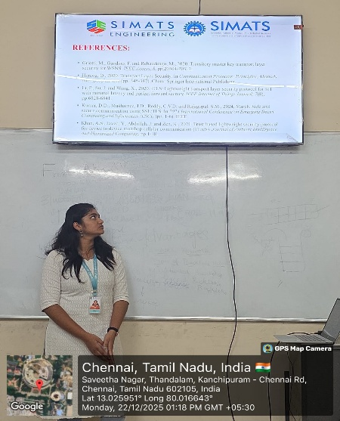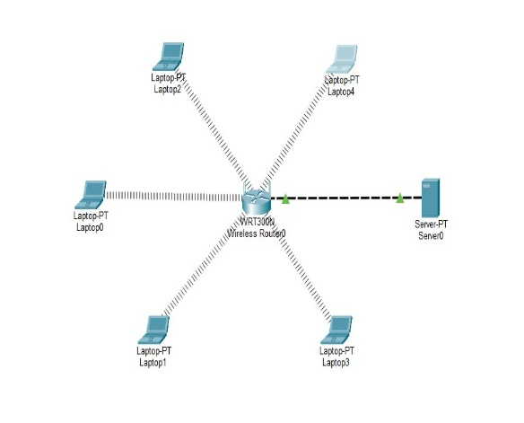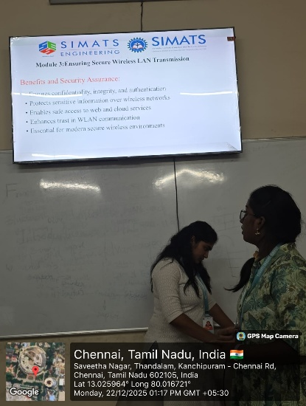
Project Description:
This project titled “Secure Data Communication in Wireless LANs Using Transport Layer Security (TLS)” focuses on improving the security of wireless communication by implementing the TLS protocol in a WLAN environment. In this project, I designed and configured a wireless network setup where secure communication is established between a client and a server using TLS encryption. I studied the TLS handshake process and implemented secure data transmission to ensure confidentiality, data integrity, and authentication over the wireless channel. I also analyzed the difference between normal wireless communication and TLS-secured communication by observing how data is protected from unauthorized access and attacks such as eavesdropping and data tampering. Through this work, I demonstrated the practical importance of TLS in securing wireless LANs and gained hands-on experience in network security concepts and secure communication protocols.

Student Signature Guide Signature

